Tamara Grove Williams  District 2 Co-Manager  Traverse City Central HS  1150 Milliken Drive  Traverse City, MI 49686  tamaragrove@msvma.org  williamsta@tcaps.net  (231) 631-0995 | 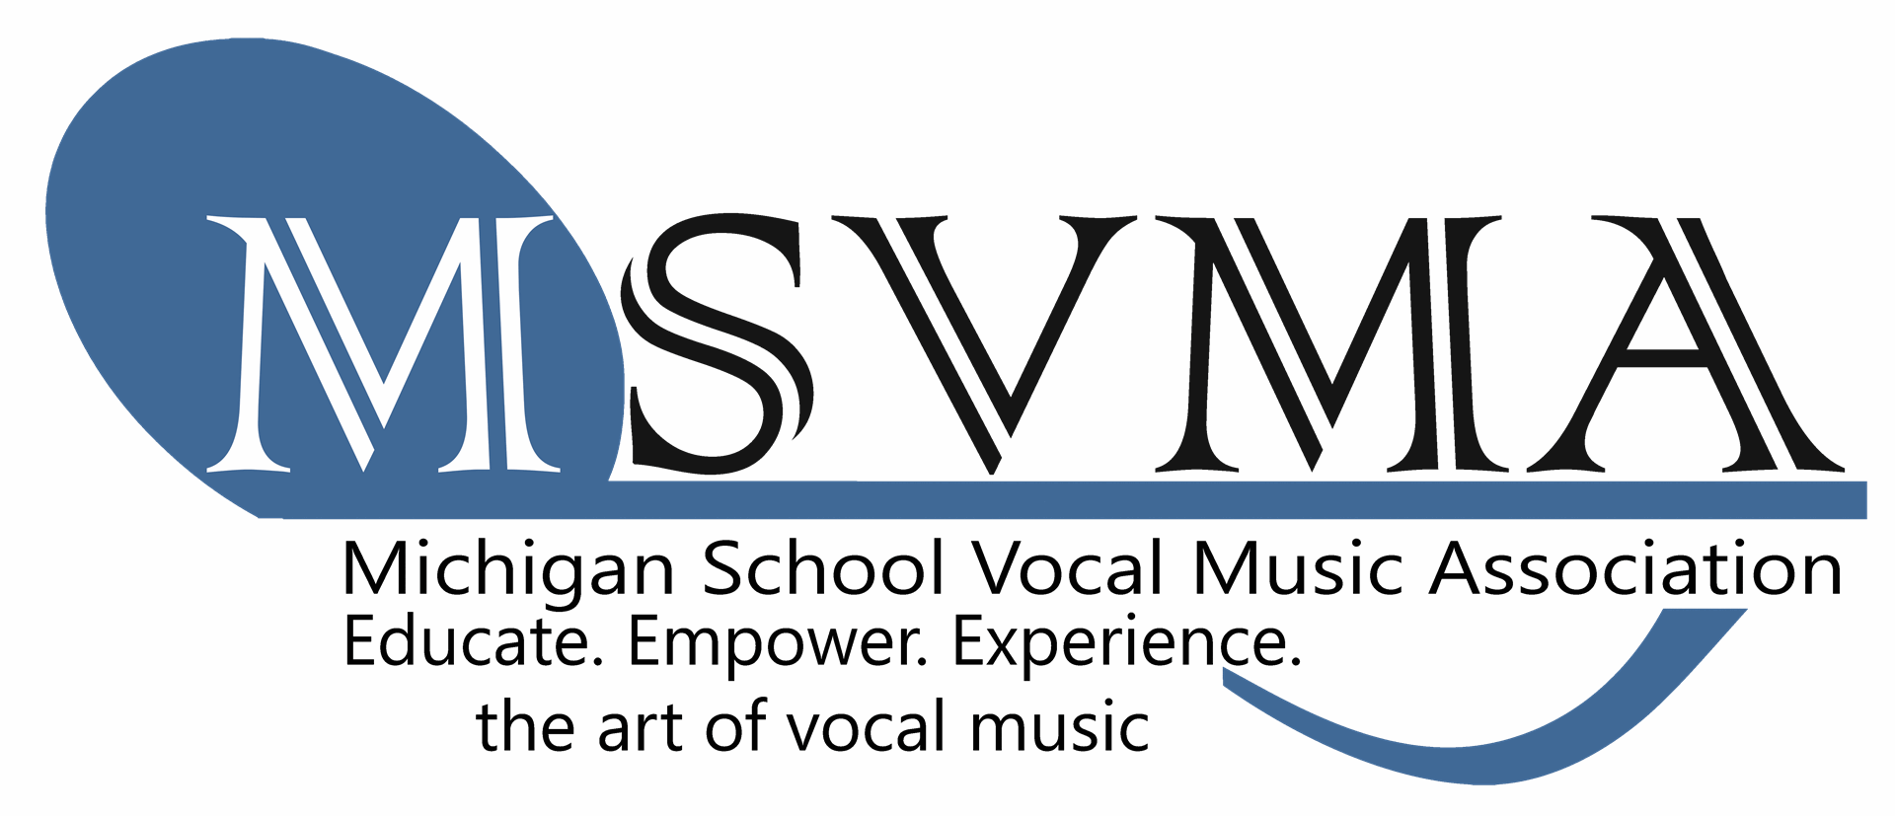 | Michele Zebell  District 2 Treasurer  Traverse City East MS  1776 North 3 Mile Road Traverse City, MI 49686  zebellmi@tcaps.net  (231) 933-7320

DISTRICT 2 Fall Meeting
Pearl’s Elk Rapids
Thursday, Sept. 22, 2017
6:00 Meeting/Dinner
Agenda (Minutes)

- Call to order and introductions: Carter, Dee, Grove Williams, Kerwin, Wolf-Schlarf, Wells, Zebell
- Approval of agenda
- Receive treasurer’s report – Michele Zebell (separate document)
- Proposals below
- MSVMA Fund Development Campaign – Ginny Kerwin
- September 15th DEADLINE for membership application – $385 Register online in “View Profile”! Please check and Update your profile info too!
- All TRANSFERS for DISTRICT and STATE EVENTS HAVE TO BE SUBMITTED BY NOV. 15, 2017 – Submit online form on MSVMA website
- Festival Registration/Application process
- Directors will register using the on-line scheduler for S&E and CHORAL FESTIVAL, just like last year... Final invoice including required signatures and paperwork must be printed, postmarked and mailed by the registration deadline. Full payment of fees and appropriate paperwork with signatures must be mailed with the invoice.
- Directors are encouraged to request payment in advance with their school districts.
- School check, cashier’s check or money order is required. Personal checks can be used, but they will be cashed.
- Changes to repertoire – 2 weeks in advance of festival!
- Honors Choir deadlines and music and State Events - see MSVMA website
- District Festivals Fees 2017-2018

S&E Fees: (postmarked by Dec. 20th)

Solo - $25

Small Ens. (2-5 singers)- $35

Large Ens. (6-20 singers) - $40

Payments received AFTER Dec. 20 deadline:
  - Solos $35, SE $40, LE $50 for fees and registration after December 20, 2016

Choral Festival Fees: (postmarked by February 3rd)
*Vote on Choral Festival Fee increase (suggested $145 per choir)
All Choral Ensembles: $135 per choir
Payments received after February 3 deadline: $160
- Dates for District 2 activities for 2017 (this year)
MS/HS Solo & Ensemble
    - Date – Saturday January 20, 8:00 a.m. – 4:30 p.m.
    - Location – Traverse City West Senior High
    - Hosts – Erich Wangeman/ Wendee Wolf-Schlarf
MS/HS Choral Festival
    - Date – February 27, 8:00 a.m. – 4:30 p.m.
    - Location – Gaylord High School
    - Host – Justin Reed
    - Date – February 28, 8:00 a.m.- 4:30 p.m. (NEED HOST)
- Proposed Dates for District 2 activities for 2019 (next year)
MS/HS Solo & Ensemble
    - Date – January 19, 2019
    - Location– Traverse City West Senior High
    - Host – Erich Wangeman/ Wendee Wolf-Schlarf
MS/HS Choral Festival
    - Date – February 28 and March 1, 2019
    - Location(s) – TBA
    - Host – TBA

- PROPOSALS from FB, Sept. 2017
• Proposal 16-09: Update Sight Reading Guidelines – Please see website for details before festival.
• Proposal 17-01: Reduce Required Number of Required Repertoire Copies at Solo & Ensemble Festival - PASSED (honor system, Director would be in legal jeopardy.
• Proposal 17-03: District Choral Festival Sight Reading – composed chorale
• Proposal 17-04: Clinician Consultant Program Addition $185 (clinician can come, or you can travel to them).
• Proposal 17-06: One Official District Manager per District, PASSED
• Proposal 17-08: Choral Festival – Inclusion of Bio for Participating Choirs
PASSED *
• Proposal 17-09: Required Repertoire Choices for MS Choirs PASSED
(allows MS singers access to sing HS level rep.)
● 17-11 Printed music for S&E festivals PASSED (have to have invoice).
● 17-12 Board Restructure proposal and timeline TABLED

- Important information from Marge Payne (read separate document).

- Executive Director Search
● Soon - Appoint a Selection Committee
● May 4, 2018– Determine details at the Ex. Bd. Mtg.
● June 1, 2018 Post the job
● Sept., 15, 2018 deadline for applications
● Sept. 15, 2018 – Dec. 1 phone interviews
● Dec. 1, 2018 – Decide whom to bring to MMC for interviews
● Jan. 24, 2019 – Live interviews (at MMC)
● Feb. 15, 2019 – Offer made and accepted
● July 1, 2019 – New person takes over

- Carolyn F. Leep Scholarship Fund
- Donations - Our District donation = $100

- Communications Plan for All D2 information -MSVMA E-MAIL!
- All correspondence for ALL DISTRICT EVENTS are directed to:
Tamara Grove Williams (tamaragrove@msvma.org)
- All correspondence for PAYMENTS are directed to:
Michele Zebell (zebellmi@tcaps.net)
- All invoices and fees are sent to:
Michele Zebell
1776 North 3 Mile Road
Traverse City, MI 49696

All STATE EVENTS are sent to STATE SUPERVISORS.
- ALL MEMBERS MUST VISIT both MSVMA and DISTRICT 2 WEBSITE FOR UPDATES AND INFORMATION

- District 2 concerns to be presented at the January 25, 2018 Full Board Meeting
*Rubrics – can we be exempt from paying for them and copy them ourselves? $49
*Restructure of the Board: general membership gets less of a vote
*MSVMA website – not user friendly!
- Other Business:

- Spring District Meeting – NONE

- Adjournment

POST-MEETING:

