Tamara Williams  District 2 Co-Manager  Traverse City Central HS  1150 Milliken Drive  Traverse City, MI 49686  tamaragrove@msvma.org  (231) 631-0995 | 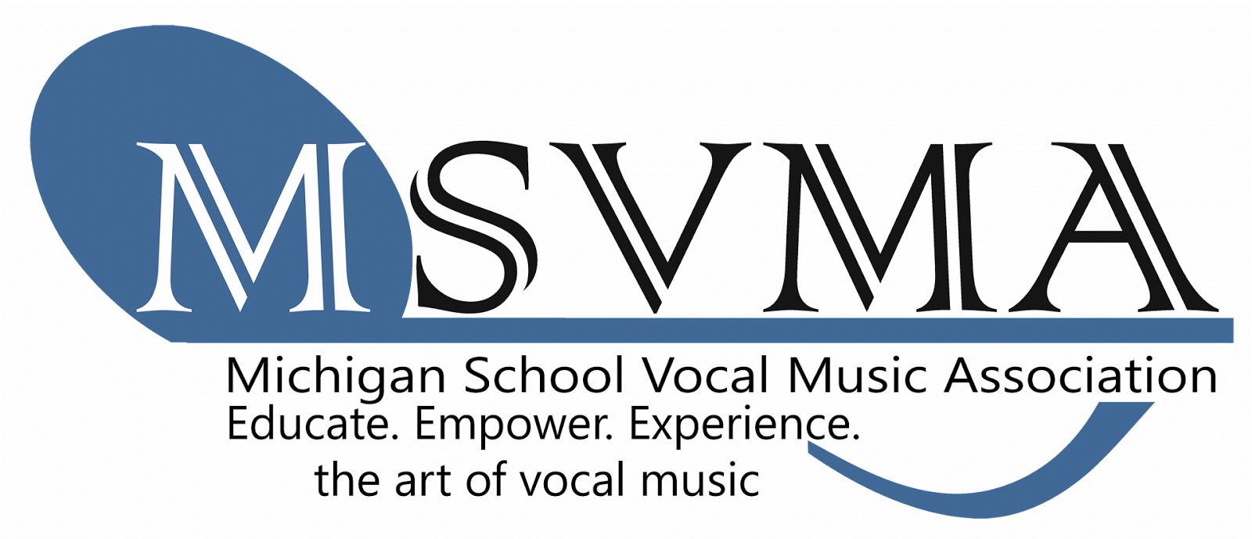 | Michele Zebell  District 2 Treasurer  Traverse City East MS  1776 North 3 Mile Road  Traverse City, MI 49696  michelezebell@msvma.org  (231) 933-7320

DISTRICT 2 Fall Meeting
Location: Pearl’s Restaurant, Elk Rapids
Date: 9/21/2018
6:00 Meeting/Dinner
Agenda (Minutes)
- Call to order and introductions
In attendance: Kerwin, Wangeman, Grove-Williams, Wolf-Schlarf, Zebell
Absent: Carter, Cline, Dee, Deike, Evans, Reed, Ross, Stow, Wells
- Approval of agenda
- Approval of your Spring 2018 District Meeting minutes
- Receive treasurer’s report – separate document (Michele Zebell)
- September 9th Full Board meeting update –
- Proposals recently passed 2016-2018
- Proposal 16-04: MMC Planning Committee Coordinator
    - Creation of the appointed position of MSVMA MMC Planning Committee Coordinator
- Proposal 16-09: Update Sight Reading Guidelines
    - JHMS Sight Reading Guidelines - Proposed Changes
HS Sight Reading Guidelines - Proposed Changes
*SEE MSVMA WEBSITE for specifics
- Proposal 17-04: Clinician Consultant Program Addition
- Proposal 17-08: Choral Festival – Inclusion of Bio for Participating Choirs
    - Allow directors to include a 50-100 word biography of their choir for adjudicators at Choral Festival.

- Proposal 17-09: Required Repertoire Choices for MS Choirs
    - Allow Middle School Choirs to choose music from any existing list, including High School Intermediate and Advanced, as their required piece for festival.

- Proposal 17-12: MSVMA New Board Structure

- Proposal 18-01: Collaboration of Singers at Solo & Ensemble Festivals
    - Allow students from multiple member schools to collaborate at District and State Solo & Ensemble Festivals, in the small ensemble (2-5 members) category
- Proposal 18-02: 6-7-8-9 Honors Choir Online Auditions
    - Grade 6-7-8-9 Honors Choir auditions will be an online video audition
- Proposal 18-03: Ensemble Participation at Musical Theatre Festival
    - Ensembles may participate in the Music Theatre Solo and Ensemble Festival; utilizing the same registration rules as traditional S&E Festivals. SEE WEBSITE
- Proposal 18-06: Volunteer Requirement for MSVMA Members
    - MSVMA school memberships will be required to volunteer assistance at events at least once a year when their students are participating in them.
      - Main office will create an awareness campaign...weekly notes-Understand each position and how they can fulfill this requirement
      - Members are responsible to keep track of how they volunteered
      - DM send out email to district members listing different opportunities to volunteer
      - We are developing the policy for members who do not volunteer
      - Next year’s registration will include questions “how did you volunteer last year” and “how would you like to serve this year?”
- Proposal 18-08: Timeline for Repertoire Submissions to Required List Dec. 1: deadline for submissions/ Announcement of the additions at the MMC
- MSVMA Fund Development Campaign - donation envelope

- September 15th DEADLINE for membership application – $385 Register online in “View Profile”! Please check and Update your profile info too!
- All TRANSFERS for DISTRICT and STATE EVENTS HAVE TO BE SUBMITTED BY NOV. 15, 2018
- Festival Registration/Application process
- Directors will register using the on-line scheduler for S&E and CHORAL FESTIVAL, just like last year... Final invoice including required signatures and paperwork must be printed, postmarked and mailed by the registration deadline. Full payment of fees and appropriate paperwork with signatures must be mailed with the invoice.
- Directors are encouraged to request payment in advance with their school districts.
- School check, cashier’s check or money order is required. Personal checks can be used, but they will be cashed.
- Changes to repertoire – 2 weeks in advance of festival!
- MSVMA ‘Handbook’ IS the newly updated MSVMA website
- Honors Choir deadlines and music and State Events - see MSVMA website
- Review District Festivals Fees 2018-2019
S&E Fees:
Solo - $25
Small Ens. (2-5 singers)- $35
Large Ens. (6-20 singers) - $40

Choral Festival Fees:
Middle School - $135 per choir (new rubrics this year)
High School - $135 per choir
- Dates for District 2 activities for 2018-2019 (this year)
HS/MS Solo & Ensemble
    - Date – Saturday, January 19, 2019
    - Location– Traverse City West Sr. High School
    - Host – Erich Wangeman/ Wendee Wolf-Schlarf
HS/MS Choral Festival
    - Date – Wednesday, February 27, 2019
    - Location – Gaylord High School
    - Host – Justin Reed
- Set Dates for District 2 activities for 2019 (next year)
HS/MS Solo & Ensemble
    - Date – Saturday, January 11, 2020
    - Location– Traverse City West Sr. High School
    - Host – Erich Wangeman/ Wendee Wolf-Schlarf
HS/MS Choral Festival Day ONE
    - Date – Thursday, February 27, 2020
    - Location – TBA
    - Host – TBA
HS/MS Choral Festival Day TWO
    - Date – Friday, February 28, 2020
    - Location – TBA
    - Host– TBA

- Carolyn F. Leep Scholarship Fund
- Donations - Our District donation = $100
- Application (due Nov. 15, 2018)
- Communications Plan for All D2 information - DM’s USE MSVMA E-MAIL!
- All Districts now have one official District Manager
- All correspondence for DISTRICT EVENTS are directed to:
Tami Williams (tamaragrove@msvma.org)
- All invoices and fees are sent to:

Michele Zebell, MSVMA
Traverse City East Middle School
1776 North 3 Mile Road
Traverse City, MI 49696

- All STATE EVENTS are sent to STATE SUPERVISORS.
- ALL MEMBERS MUST VISIT both MSVMA and DISTRICT 2 WEBSITE FOR UPDATES AND INFORMATION
- District 2 concerns to be presented at the January 25, 2019 Full Board Meeting
- Other Business
- Spring District Meeting – NO SPRING MEETING
- Adjournment

POST-MEETING/addendums:

